North Carolina State University
2010 Sophomore Student Survey:
All Respondents
This overview report presents findings from all sophomore students participating in the 2010 Sophomore Student Survey. For information about the survey methods and analysis, see "2010 Sophomore Student Survey: Introduction, Methods, and Student Demographic Profile." For additional responses broken down by gender, race/ethnicity, and college, as well as a copy of the survey instrument with exact question wording, see the Table of Contents.

Table of Contents:
General Satisfaction
Satisfaction with NC State
Withdrawal/Transfer from NC State
Academic Environment and Faculty Contributions
Academic Environment
Classroom Environment
Satisfaction with Instruction
Faculty-Student Mentoring
Academic Advising
Campus Climate and Safety
Diversity at NC State
Campus Climate for Student Groups
Campus Community
Campus Safety
Student Services
Services Outside the Classroom
Non-Academic Service Areas
University Online Systems
Financial Aid
Knowledge, Skills and Personal Development
Employment and Extracurricular Activities
Employment
Involvement in Campus Activities

General Satisfaction
This section of the report presents respondents' reports of satisfaction with NC State and plans for degree completion.
Satisfaction with NC State (Table 1)
Sophomores' overall satisfaction with NC State is high. More than 80 percent of respondents agreed that they were confident they made the right decision to attend NC State (88.3%), were academically prepared to attend NC State (83.4%), and feel they belong at NC State (81.2%). Slightly fewer respondents agreed that they would still choose to attend NC State if starting over (77.4%) and that they will have the financial resources needed to finish college (68.2%).
Table 1: Satisfaction with NC State
 | Mean | 5: Strongly  agree | 4: Agree | 3: Neither agree  nor disagree | 2: Disagree | 1: Strongly  disagree
I am confident that I made the right decision to attend NC State | 4.40 | 56.6% | 31.7% | 7.7% | 3.4% | 0.6%
I would still choose to attend NC State if starting over | 4.20 | 51.4% | 26.0% | 15.3% | 5.5% | 1.7%
I believe I was academically prepared to attend NC State | 4.21 | 49.4% | 34.0% | 7.4% | 7.0% | 2.3%
I feel I belong at NC State | 4.20 | 46.2% | 35.0% | 13.1% | 4.1% | 1.5%
Withdrawal/Transfer from NC State (Tables 2, 3 and 4)
Over 90 percent of respondents (94.4%) said they plan to complete their degree at NC State. About half (45.9%) of the sophomore respondents, however, reported that they had considered withdrawing or transferring from NC State, although the majority of that group said they had not seriously considered doing so (63.0%)
When asked to indicate why they had considered leaving, over forty percent (40.4%) of the potential "leavers" indicated that it was related to an academic program or curriculum - either dissatisfaction with a curriculum or program at NC State, or desiring one (e.g., Nursing) that NC State does not offer. About one-fourth of those who had considered leaving cited reasons related to campus life (26.4%; e.g., not being able to get involved, not liking the campus environment, etc.) or gave personal reasons (22.1%; e.g., stress, medical reasons, etc.). About one-in-ten of those who thought about leaving said it was due to financial concerns.
Table 2: Educational Plans
Description of current educational plans | % | N
Expect to be continually enrolled at NC State until graduate | 93.0% | 910
Expect to graduate from NC State, but take time off between semesters | 1.4% | 14
Expect to transfer to another college or university in order to pursue desired major | 2.5% | 24
Expect to transfer to another college or university for reasons unrelated to major | 0.8% | 8
Do not expect to complete degree at NC State or other college in forseeable future | 0.2% | 2
Not sure about educational plans at this point | 2.0% | 20

Table 3: Withdraw/Transfer from NC State
Ever consider withdrawing or transferring from NC State | % | N
No | 54.1% | 530
Yes, not seriously | 28.9% | 283
Yes, seriously | 15.4% | 151
Yes, left and came back | 1.5% | 15

Table 4: Reasons for considering leaving NC State (among those who considered leaving or left and returned, n=235)
 | % | N
Academic program | 40.4% | 95
Campus life | 26.4% | 62
Personal reasons | 22.1% | 52
Financial reasons | 9.4% | 22
Class environment | 8.1% | 19
Location | 8.1% | 19
Poor performance | 4.3% | 10
Advising | 3.8% | 9
Initially wanted to attend different school | 3.8% | 9
Non-academic opportunity | 2.6% | 6
Diversity | 1.7% | 4
*Note: Respondents could offer more than one reason.

Academic Environment and Faculty Contributions
This section of the report presents respondents' evaluations of the academic environment at NC State, their satisfaction with instruction and academic advising, and their experiences with faculty-student mentoring.
Academic Environment (Tables 5 and 6)
More than 90 percent of respondents characterized the overall intellectual environment on NC State's campus as either "very strong" (27.4%) or "strong" (66.8%).
Sophomores gave overwhelmingly positive ratings to several specific items related to the academic environment at NC State. They were most likely to agree that experiences at NC State have stimulated interest in an intended field of study (86.0%) and that they consider what they have been learning in classes valuable (87.7%). Respondents were slightly less likely to agree that students at NC State are given meaningful answers to the questions they ask (78.7%).
Table 5: Intellectual Environment
 | Mean | 4: Very strong | 3: Strong | 2: Weak | 1: Very weak
Intellectual environment on campus | 3.21 | 27.4% | 66.8% | 5.6% | 0.2%

Table 6: Academic Environment
 | Mean | 5: Strongly  agree | 4: Agree | 3: Neither agree  nor disagree | 2: Disagree | 1: Strongly  disagree
My experiences at NC State have stimulated interest in an intended field of study | 4.19 | 38.4% | 47.6% | 9.6% | 3.5% | 0.9%
I consider what I have been learning in my classes valuable | 4.13 | 30.2% | 57.5% | 8.3% | 3.4% | 0.6%
Students at NC State are encouraged to ask questions | 4.11 | 30.6% | 52.6% | 13.8% | 2.5% | 0.4%
At NC State, students are invited to share their ideas and knowledge | 4.10 | 30.2% | 52.7% | 14.3% | 2.2% | 0.6%
I am able to freely explore academic interests at NC State | 3.98 | 29.2% | 49.6% | 13.2% | 6.0% | 1.9%
Students at NC State are given meaningful answers to the questions they ask | 3.97 | 22.4% | 56.3% | 18.1% | 2.7% | 0.5%

Classroom Environment (Figure 1)
About 80 percent of respondents reported that during their time at NC State they had had at least one class that was too large to learn effectively (80.2%) and one class in which they had difficulty understanding the spoken English of the instructor (79.4%). More than two-thirds of respondents reported having had three or more classes that were too large to learn effectively (35.8%), and one-fifth reported having had three or more classes where the instructor’s English was difficult to understand (20.0%).
Figure 1: Class Size and Instructor's Spoken English
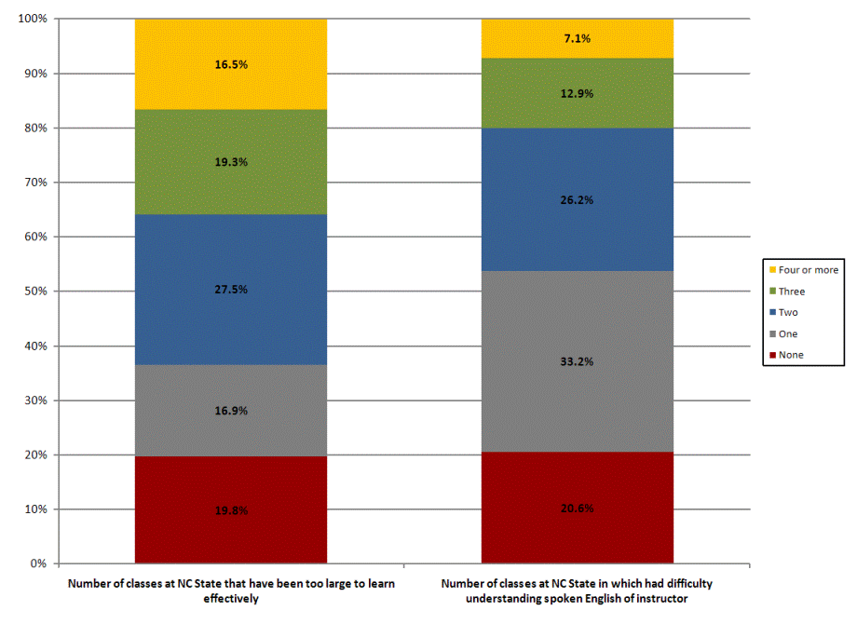
Satisfaction with Instruction (Table 7)
A majority of respondents gave positive ratings to various items related to quality of instruction at NC State. When asked about the overall quality of instruction at NC State, 85 percent of respondents said they were either "very satisfied" (16.3%) or "satisfied" (68.7%). Over 80 percent of respondents reported being either "very satisfied" or " satisfied" with instructors for how effectively they use instructional technology (83.9%), and how carefully they explain the expectations of student performance (83.7%). Of the items asked about, respondents were least likely to be satisfied with the extent to which instructors encouraged class discussion (69.4% saying they were at least "satisfied").
Table 7: Satisfaction with Instruction
 | Mean | 5: Very  satisfied | 4: Satisfied | 3: Neither satisfied  nor dissatisfied | 2: Dissatisfied | 1: Very  dissatisfied
Satisfaction with instructors: How effectively they use instructional technology | 4.05 | 24.9% | 59.0% | 12.9% | 2.9% | 0.3%
Satisfaction with instructors: How carefully they explain the expectations of student performance | 3.96 | 16.8% | 66.9% | 12.4% | 3.7% | 0.2%
Satisfaction with instructors: How well they explain course material | 3.88 | 12.8% | 66.7% | 16.5% | 3.8% | 0.3%
Satisfaction with instructors: Respecting the diverse talents and ways of learning | 3.85 | 17.7% | 55.7% | 20.8% | 5.1% | 0.6%
Satisfaction with instructors: How quickly they provide feedback on my work | 3.82 | 18.0% | 54.3% | 19.8% | 7.5% | 0.5%
Satisfaction with instructors: The helpfulness of their feedback on my work | 3.78 | 15.6% | 55.4% | 21.4% | 6.9% | 0.7%
Satisfaction with instructors: Ability to motivate me to do my best | 3.78 | 11.5% | 60.8% | 21.7% | 5.5% | 0.4%
Satisfaction with instructors: The extent to which they encourage class discussion | 3.76 | 14.8% | 54.6% | 23.5% | 6.2% | 0.9%
Overall quality of instruction | 3.99 | 16.3% | 68.7% | 12.5% | 2.3% | 0.2%

Faculty-Student Mentoring (Table 8)
Of the mentoring experiences asked about, respondents were most likely to have met regularly with faculty for academic guidance (38.0%) or professional guidance (24.2%), and to have worked with faculty on campus activities (19.0%). Less than 10 percent of respondents reported having worked on extension/public service projects with faculty (7.1%), worked on non course-related research with faculty (6.9%), worked on an independent study with faculty (5.9%), or assisted teaching a class/lab with faculty guidance (4.4%). All mentoring experiences, however, were very highly rated by participants in terms of contribution to their personal and/or professional growth.
Table 8: Faculty-Student Mentoring
Faculty-Student Mentoring | Yes, had experience |  | Experience's Contribution to Personal/Professional Growth
Faculty-Student Mentoring | N | % | Mean | 4: Very much | 3: Somewhat | 2: Very little | 1: Not at all
Regularly met with a faculty member who provided academic guidance | 359 | 38.0% | 3.41 | 52.8% | 36.4% | 9.3% | 1.5%
Regularly met with a faculty member who provided professional guidance and/or support | 228 | 24.2% | 3.44 | 56.2% | 31.3% | 12.4% | 0.0%
Worked with faculty member on campus activities (e.g., committees, student life activities, etc.) | 180 | 19.0% | 3.38 | 45.0% | 48.8% | 5.6% | 0.6%
Regularly met with a faculty member who provided guidance on non-academic issues | 113 | 11.9% | 3.44 | 56.3% | 32.0% | 10.7% | 1.0%
Worked on extension/public service project with faculty member outside of course/program | 68 | 7.1% | 3.28 | 34.4% | 59.0% | 6.6% | 0.0%
Worked on research project with faculty member outside of course/program requirements | 66 | 6.9% | 3.33 | 49.2% | 34.4% | 16.4% | 0.0%
Worked on an independent study project with a faculty member | 56 | 5.9% | 3.24 | 43.1% | 41.2% | 11.8% | 3.9%
Assisted in teaching a class or lab under the guidance of a faculty member | 42 | 4.4% | 3.42 | 52.8% | 36.1% | 11.1% | 0.0%
Comparisons and Frequencies: Gender/Ethnicity, College
Back to Top
Academic Advising (Tables 9-11)
A majority of respondents (53.9%) said their primary source for academic advising was "a professional advisor in my department or college." Another 30 percent said their primary source for advising was a "faculty member in their my department". Less than 10 percent said their primary source was NC State's Virtual Advising Center (7.8%).
Respondents were asked to rate their satisfaction with several aspects of academic advising. Ratings were overwhelmingly positive, with a majority of respondents being either "very satisfied" or "satisfied" with each of the 12 aspects asked about. Respondents were most likely to be "very satisfied" with their advisor's knowledge about the requirements for current major or major of interest (41.4%). They were most likely to be dissatisfied with advisor keeping me informed about my academic progress (15.5% either "dissatisfied" or "very dissatisfied").
Nearly two-thirds (63.5%) of respondents said they did not know about or did not use NC State's Virtual Advising Center website. Of those who had used the website, more than 70 percent gave it a rating of "excellent" (10.1%) or "good" (62.8%).
Table 9: Primary Source for Academic Advising
Primary source for academic advising during sophomore year | % | N
Professional advisor in my department or college | 53.9% | 536
Faculty member in my department | 29.7% | 295
NC State provided web-based advising site (i.e., Virtual Advising Center) | 7.8% | 78
Centralized or campus-wide advising service (with personal contact) | 3.8% | 38
Other | 4.7% | 47
Table 10: Satisfaction with Academic Advising
 | Mean | 5: Very  satisfied | 4: Satisfied | 3: Neither satisfied  nor dissatisfied | 2: Dissatisfied | 1: Very  dissatisfied
Advisor’s knowledge about the requirements for current major or major of interest | 4.12 | 41.4% | 37.6% | 14.2% | 5.1% | 1.6%
Advisor’s knowledge about general education and other degree requirements | 4.00 | 34.8% | 39.7% | 18.2% | 5.4% | 1.9%
Advisor’s knowledge about university rules and procedures | 3.98 | 33.5% | 40.3% | 19.3% | 4.8% | 2.0%
Accessibility of my primary advisor | 3.97 | 35.9% | 39.4% | 13.5% | 8.6% | 2.6%
Amount of time I am given during advising sessions | 3.97 | 33.6% | 41.3% | 16.2% | 6.3% | 2.5%
Advisor providing me with the information about academic courses and program | 3.94 | 33.9% | 39.5% | 16.0% | 7.9% | 2.7%
Advisor’s concern with my academic success | 3.87 | 32.6% | 36.7% | 19.2% | 8.3% | 3.3%
Advisor knowing whom to contact to help with non-academic problems | 3.77 | 26.8% | 31.6% | 35.4% | 4.5% | 1.6%
Advisor’s knowledge about post-graduation educational options | 3.68 | 22.8% | 30.3% | 41.0% | 4.0% | 1.8%
Advisor’s encouragement of participation in educational enrichment opportunities | 3.67 | 25.0% | 32.1% | 30.9% | 8.7% | 3.3%
Advisor’s knowledge about post-graduation employment options | 3.64 | 21.7% | 28.6% | 43.4% | 4.7% | 1.6%
Advisor keeping me informed about my academic progress | 3.63 | 26.4% | 30.6% | 27.6% | 11.0% | 4.5%

Table 11: Virtual Advising Center
 | Mean | 4: Excellent | 3: Good | 2: Fair | 1: Poor
Overall rating of NC State's Virtual Advising Center Web site (among those who have used, N=358) | 2.78 | 10.1% | 62.8% | 22.6% | 4.5%

Campus Climate and Safety

This section explores students' attitudes toward diversity on campus, including NC State's commitment to helping minority students succeed and to fostering diversity on campus, how supportive the campus environment is toward various student groups, and the sense of community at NC State. Campus safety issues, including how safe students feel in certain campus locations and the availability of crime information on campus, are also presented.
Diversity at NC State (Figure 2)
Respondents overall were generally satisfied with issues related to diversity at NC State. Half of students (50.2%) "strongly agree" and another 45.6 percent "agree" that NC State is committed to helping minorities succeed . Although still a majority, respondents were less likely to agree that there is visible leadership to help foster diversity on NC State's campus (32.1% "strongly agree" and 47.7% "agree").
Figure 2: Diversity at NC State
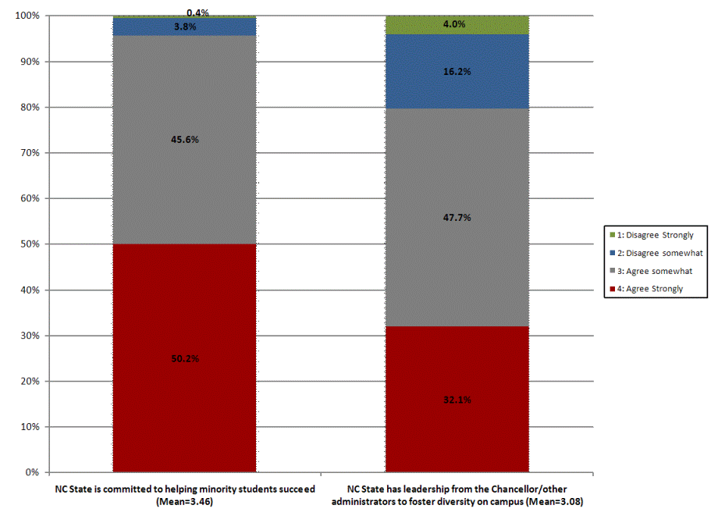
Campus Climate for Student Groups (Table 12)
Respondents were asked their opinion on how supportive the campus is toward different groups of students (e.g., women, African Americans, students with disabilities, etc.). With one exception, 40 percent or more respondents said that the campus is "strongly supportive" of the various student groups asked about. Only 29 percent of respondents said the campus is "strongly supportive" of gay, lesbian, bisexual, and transgender students. Furthermore, about 12 percent of respondents said the campus is non-supportive of gay, lesbian, bisexual, and transgender students - more than twice the number giving such a rating to any other group asked about.
Table 12: Campus Climate for Student Groups
 | Mean | 5: Strongly  supportive | 4: Mildly  supportive | 3: Neutral | 2: Mildly  nonsupportive | 1: Strongly  nonsupportive
Women | 4.33 | 52.5% | 29.6% | 16.8% | 1.2% | 0.0%
Men | 4.32 | 55.4% | 23.4% | 19.5% | 0.9% | 0.8%
African Americans | 4.20 | 47.4% | 28.4% | 21.5% | 1.8% | 0.8%
International students | 4.13 | 42.5% | 31.5% | 23.2% | 2.3% | 0.5%
Other ethnic minorities | 4.08 | 39.6% | 32.7% | 24.5% | 2.6% | 0.6%
Students with disabilities | 4.03 | 40.2% | 28.5% | 26.5% | 3.8% | 1.0%
Gay, lesbian, bisexual, and transgender students | 3.71 | 29.0% | 28.4% | 31.0% | 8.1% | 3.5%

Campus Community (Table 13)
About 85 percent of respondents stated that it was "very" (47.8%) or "moderately important" (36.4%) to personally experience a sense of community at NC State, and 79 percent of all respondents said they actually did experience a sense of community to either a "great extent" (32.8%) or to "some extent" (46.2%). There is a clear relationship between sophomores' beliefs about the importance of feeling a sense of community at NC State and actually having that experience. In general, respondents who believed it was important to experience a sense of community at NC State responded that they experienced such community to at least some extent. Only about 1 percent of respondents who thought it was "very important" to experience a sense of community did not experience it at all, and another 9.2 percent of said they experienced it only to "a small extent." Conversely, those who saw it as less important generally reported feeling less connected to NC State.
Table 13: Sense of Community at NC State
Importance of experiencing a sense of belonging or community at NC State | Extent to which experience sense of belonging or community at NC State |  |  |  | Total
 | 4: To a great  extent | 3: To some  extent | 2: To a small  extent | 1: Not at all | Total
4: Very important (N=467) | 52.9% | 36.8% | 9.2% | 1.1% | 47.8%
3: Moderately important (N=356) | 19.1% | 61.0% | 16.3% | 3.7% | 36.4%
2: Slightly important (N=120) | 4.2% | 46.7% | 41.7% | 7.5% | 12.3%
1: Not at all important (N=35) | 2.9% | 20.0% | 42.9% | 34.3% | 3.6%
Total (N=978) | 32.8% | 46.2% | 17.0% | 4.0% | 100.0%

Campus Safety (Table 14)
Sophomores were asked how safe they feel in various campus locations at various times of day and night. Ratings varied greatly, with outdoor locations at night receiving the lowest ratings. More than two-thirds of respondents reported feeling "very safe" in campus residence halls during the day/early evening (67.8%). In contrast, 40 percent of respondents said they feel "not at all safe"(10.3%) or "not very safe" (29.6%) outside on the grounds of the campus at night and one-third say they feel "not at all safe"(6.0%) or "not very safe" (28.5%) using the parking lots, garages, and/or decks on campus at night.
Table 14: Campus Safety
 | Mean | 4: Very safe | 3: Pretty safe | 2: Not very safe | 1: Not at all safe
In campus residence halls during the day/early evening | 3.67 | 67.8% | 31.1% | 0.8% | 0.2%
In non-residence buildings on campus during the day/early evening | 3.57 | 59.3% | 38.7% | 1.3% | 0.7%
Outside on the grounds of the campus during the day/early evening | 3.44 | 48.7% | 48.1% | 2.1% | 1.1%
Using the parking lots, garages and/or decks on campus during the day/early evening | 3.43 | 46.8% | 49.8% | 2.6% | 0.8%
In campus residence halls at night | 3.42 | 47.6% | 47.5% | 3.9% | 1.0%
In non-residence buildings on campus at night | 3.16 | 31.3% | 55.7% | 10.9% | 2.1%
Using the parking lots, garages, and/or decks on campus at night | 2.73 | 13.2% | 52.3% | 28.5% | 6.0%
Outside on the grounds of the campus at night | 2.60 | 10.4% | 49.7% | 29.6% | 10.3%

Availability of Crime and Safety Information (Figure 3)
More than 80 percent of respondents reported being either "very satisfied" (31.3%) or "satisfied" (49.8%) with the availability of public information about crimes on campus. Respondents were slightly less satisfied with the availability of information about crime prevention/safety on campus although three-fourths were at least "satisfied" (75.1%).
Figure 3: Availability of Information Relating to Campus Safety
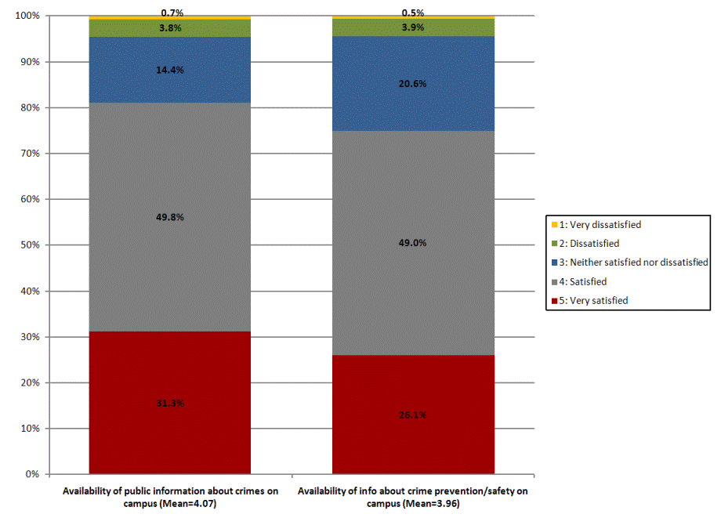
Crime Reporting (Tables 15 and 16)
While a majority of respondents (61.3%) said they knew how to report suspicious or threatening behavior, less than one-third (31.3%) said they were "very likely" to report such behavior to campus authorities.
Table 15: Know How to Report Suspicious or Threatening Behavior
 | % | N
Know how to report suspicious or threatening behavior on campus | 61.3% | 603

Table 16: Likelihood of Reporting Suspicious or Threatening Behavior
Likelihood of reporting suspicious or threatening behavior to campus authority | % | N
Very likely | 31.3% | 308
Somewhat likely | 51.8% | 509
Somewhat unlikely | 14.0% | 138
Very unlikely | 2.8% | 28

Student Services
This section examines respondents' satisfaction with various academic and non-academic student services, university online systems, and financial aid services.
Services Outside the Classroom (Tables 17-22)
Respondents were asked to rate 29 specific services, divided into 6 categories: academic assistance and tutoring, research support, library, career services, information technology, and the campus bookstore. Ratings range from 1 ("very dissatisfied") to 5 ("very satisfied"). "Don't know" and "Did not use" responses are excluded from the analyses. Respondents appear to be satisfied with all such services, with less than 6 percent saying they were "very dissatisfied" with any one of the 29 individual services asked about. Library hours of operation (4.37) received the highest average rating and opportunities to be involved with faculty on their research (3.28) received the lowest average rating.
Academic Assistance and Tutoring: Respondent ratings varied for the different areas of academic assistance and tutoring. Respondents were most likely to be "satisfied" with the availability of academic assistance or tutoring services on campus (73.1%) and with academic assistance or tutoring in mathematics (72.1%). They were least likely to be "satisfied" with academic assistance or tutoring in reading (48.4%). As noted earlier, these tables exclude "Don't know/Not applicable" responses. With the exception of availability of academic assistance or tutoring services on campus, the number of students selecting "Don't know/Not applicable" was much larger for these items than for the other service areas asked about.
Table 17: Academic Assistance and Tutoring
 | Mean | 5: Very  satisfied | 4: Satisfied | 3: Neither satisfied  nor dissatisfied | 2: Dissatisfied | 1: Very  dissatisfied
Availability of academic assistance or tutoring services on campus | 3.82 | 20.2% | 52.9% | 17.8% | 7.1% | 2.0%
Academic assistance or tutoring: Writing | 3.83 | 20.5% | 46.6% | 29.0% | 3.2% | 0.7%
Academic assistance or tutoring: Mathematics | 3.81 | 19.1% | 53.0% | 19.4% | 7.1% | 1.4%
Academic assistance or tutoring: Science | 3.80 | 20.2% | 50.1% | 20.9% | 7.4% | 1.4%
Academic assistance or tutoring: Study skills | 3.59 | 14.4% | 40.6% | 37.6% | 4.8% | 2.6%
Academic assistance or tutoring: Reading | 3.58 | 14.7% | 33.7% | 48.4% | 1.6% | 1.6%
Academic assistance or tutoring: Foreign language | 3.58 | 13.8% | 37.2% | 43.9% | 3.1% | 2.0%
Research Support: Sophomores were almost twice as likely to say they were "very satisfied" with access to up-to-date facilities than to say they were "very satisfied" with opportunities to be involved with faculty on their research. In fact, more than one-fifth of respondents reporting being either "dissatisfied" (17.6%) or "very dissatisfied" (4.4%) with such opportunities.
Table 18: Research Support
 | Mean | 5: Very  satisfied | 4: Satisfied | 3: Neither satisfied  nor dissatisfied | 2: Dissatisfied | 1: Very  dissatisfied
Access to up-to-date facilities | 3.78 | 21.4% | 45.7% | 24.7% | 5.7% | 2.5%
Opportunities to be involved with faculty on their research | 3.28 | 12.4% | 29.0% | 36.6% | 17.6% | 4.4%

Library: Overall, respondents were very satisfied with the library services asked about, with over two-thirds of respondents saying they were at least "satisfied" with 5 of the 7 items. Ratings were particularly high for hours of operation, with 92 percent saying they were "satisfied." Close to one-fourth of respondents were dissatisfied with the library's space for group work (24.0%) and about one-fifth were dissatisfied with space for individual student work in the library (18.4%).
Table 19: Library
 | Mean | 5: Very  satisfied | 4: Satisfied | 3: Neither satisfied  nor dissatisfied | 2: Dissatisfied | 1: Very  dissatisfied
Hours of operation | 4.37 | 46.8% | 45.0% | 6.9% | 1.1% | 0.2%
Access to online library resources | 4.20 | 32.4% | 57.0% | 8.6% | 1.5% | 0.4%
Helpfulness of staff | 4.06 | 26.9% | 55.5% | 14.7% | 2.5% | 0.5%
Availability of information/material I need for my class assignments | 4.02 | 23.7% | 58.3% | 14.9% | 2.5% | 0.5%
Training/instruction for using library and information resources | 3.71 | 17.8% | 44.6% | 29.5% | 6.4% | 1.7%
Space for individual student work | 3.69 | 21.1% | 48.4% | 12.2% | 14.9% | 3.5%
Space for group work | 3.50 | 17.2% | 45.3% | 13.6% | 18.3% | 5.7%
Information Technology: Overall, respondents gave consistently high ratings to information technology services available on campus, with about two-thirds or more respondents being at least "satisfied" with each of the services asked about. Hours of operation for university computer labs received the highest average rating, with 79 percent saying they were "very satisfied" or "satisfied." Students were least satisfied with online course management system(s) used in my classes (14.9% saying "dissatisfied" or "very dissatisfied"). Respondents were somewhat divided in their assessment of wireless access on campus, with 31 percent being "very satisfied" (the highest such rating for any information technology service, and one of the highest for all academic services asked about), and 10 percent being dissatisfied with it.
Table 20: Information Technology
 | Mean | 5: Very  satisfied | 4: Satisfied | 3: Neither satisfied  nor dissatisfied | 2: Dissatisfied | 1: Very  dissatisfied
Hours of operation for university computer labs | 3.99 | 24.2% | 54.5% | 17.9% | 3.1% | 0.3%
Availability of wireless access on campus | 3.98 | 31.2% | 47.6% | 11.3% | 8.4% | 1.5%
Availability of equipment and software in university computer labs | 3.97 | 23.2% | 55.4% | 17.1% | 3.3% | 0.9%
Assistance from the helpdesk in solving my technology problems | 3.83 | 19.8% | 50.2% | 24.7% | 3.8% | 1.5%
Effectiveness of information technology in improving my learning experience | 3.83 | 17.1% | 54.1% | 24.3% | 3.4% | 1.0%
Training on the technology that I am required to use in my courses | 3.69 | 14.7% | 52.2% | 22.9% | 7.9% | 2.4%
Online course management system(s) used in my classes | 3.63 | 15.7% | 49.7% | 19.7% | 11.5% | 3.4%

Career Services: Ratings were consistently positive for career services, with little variation in ratings of individual services. Seventy percent or more respondents were at least "satisfied" with each of the career services asked about. Ratings were particularly high for helpfulness of staff and access to employment opportunities, with which more than three-fourths of respondents said they were "very satisfied" or "satisfied."
Table 21: Career Services
 | Mean | 5: Very  satisfied | 4: Satisfied | 3: Neither satisfied  nor dissatisfied | 2: Dissatisfied | 1: Very  dissatisfied
Helpfulness of staff | 3.96 | 20.9% | 56.5% | 20.9% | 1.3% | 0.4%
Access to employment opportunities (e.g., career fairs, interviews, etc.) | 3.91 | 23.0% | 52.7% | 18.0% | 5.0% | 1.3%
Help in preparing for interviews, resumes, etc. | 3.86 | 21.0% | 49.6% | 24.4% | 4.2% | 0.8%
Information on internships, co-ops, and other career-related experiences | 3.83 | 19.3% | 53.6% | 19.9% | 5.5% | 1.7%
Availability of career resources online | 3.83 | 18.5% | 52.1% | 24.2% | 3.9% | 1.2%
Bookstore: More than three-fourths of respondents (76.2%) were satisfied with the timely availability of course materials at the bookstore.
Table 22: Bookstore
 | Mean | 5: Very  satisfied | 4: Satisfied | 3: Neither satisfied  nor dissatisfied | 2: Dissatisfied | 1: Very  dissatisfied
Timely availability of textbooks, computer supplies, etc. | 3.88 | 21.5% | 54.7% | 16.1% | 5.5% | 2.2%
Non-Academic Service Areas (Tables 23 and 24)
Respondents were asked to indicate their satisfaction with various non-academic service areas and the quality of the staff associated with the service. Service ratings range from 1 ("very dissatisfied") to 5 ("very satisfied") and quality of staff ratings range from 1 ("poor") to 5 ("excellent"). "Don't know" and "Did not use" responses are excluded from the analyses.
Ratings for service areas varied greatly, with anywhere from 4 percent (parking) to 30 percent (Health Services) of respondents saying they were "very satisfied" with a particular service. Ratings for quality of staff generally mirror those for the service itself. Similar to the "service" ratings, Health Services staff were more likely than staff from other areas to be rated as "excellent" (34.7%) and staff associated with parking the least likely (11%).
Table 23: Evaluation of Non-Academic Service Areas
 | Mean | 5: Very  satisfied | 4: Satisfied | 3: Neither satisfied  nor dissatisfied | 2: Dissatisfied | 1: Very  dissatisfied
Campus Recreation | 4.03 | 25.7% | 55.8% | 15.4% | 2.5% | 0.6%
Campus Bookstore | 3.97 | 21.8% | 60.0% | 13.5% | 2.9% | 1.8%
Health Services | 3.94 | 29.8% | 47.3% | 13.0% | 6.7% | 3.2%
Counseling (personal, interpersonal, or psychological) | 3.83 | 22.9% | 47.7% | 22.2% | 4.4% | 2.8%
Registrar’s Office | 3.82 | 17.9% | 53.6% | 22.7% | 4.1% | 1.6%
Campus Police Department | 3.80 | 19.1% | 52.1% | 21.4% | 4.4% | 3.0%
On-campus shuttle/transportation services | 3.76 | 18.8% | 54.1% | 14.8% | 9.0% | 3.3%
Financial Aid: Disbursement process | 3.74 | 21.5% | 47.5% | 18.1% | 9.4% | 3.6%
Financial Aid: Application/award process | 3.73 | 22.3% | 46.7% | 16.9% | 10.3% | 3.8%
Cashier/Student Accounts/Billing Office | 3.69 | 16.3% | 50.8% | 21.1% | 9.0% | 2.8%
Housing and Residence Life | 3.69 | 16.4% | 52.7% | 18.3% | 8.4% | 4.2%
Dining Services | 3.29 | 9.8% | 43.7% | 21.2% | 16.7% | 8.6%
Parking | 2.52 | 4.4% | 22.8% | 17.7% | 30.0% | 25.1%

Table 24: Quality of Non-Academic Service Staff
 | Mean | 5: Excellent | 4: Good | 3: Average | 2: Fair | 1: Poor
Health Services | 4.04 | 34.7% | 43.8% | 14.8% | 4.7% | 2.0%
Campus Recreation | 4.01 | 25.6% | 53.8% | 17.6% | 2.1% | 0.8%
Campus Bookstore | 3.95 | 24.6% | 50.4% | 21.3% | 3.0% | 0.7%
Counseling (personal, interpersonal, or psychological) | 3.89 | 26.4% | 45.3% | 21.1% | 5.3% | 1.9%
On-campus shuttle/transportation services | 3.85 | 26.1% | 43.9% | 21.5% | 5.4% | 3.1%
Financial Aid: Disbursement process | 3.84 | 24.0% | 45.8% | 23.6% | 3.1% | 3.5%
Financial Aid: Application/award process | 3.82 | 24.1% | 45.5% | 22.7% | 3.3% | 4.4%
Registrar’s Office | 3.82 | 20.9% | 49.0% | 24.3% | 2.5% | 3.3%
Campus Police Department | 3.81 | 23.8% | 47.2% | 20.5% | 4.0% | 4.6%
Cashier/Student Accounts/Billing Office | 3.73 | 20.3% | 46.0% | 24.5% | 5.0% | 4.2%
Housing and Residence Life | 3.71 | 18.6% | 47.0% | 25.2% | 4.8% | 4.4%
Dining Services | 3.46 | 16.7% | 39.1% | 25.3% | 11.5% | 7.5%
Parking | 3.07 | 11.1% | 32.7% | 26.2% | 11.9% | 18.1%

University Online Systems (Figure 4)
Respondents were asked to indicate their satisfaction with the ease of use of several of the university's online systems. Ratings were fairly consistent, with about two-thirds saying they were at least "satisfied" with the online financial aid system (66.6%) the billing system (66.2%), and the course registration system (66.9%).
Figure 4: Evaluation of University Online Systems
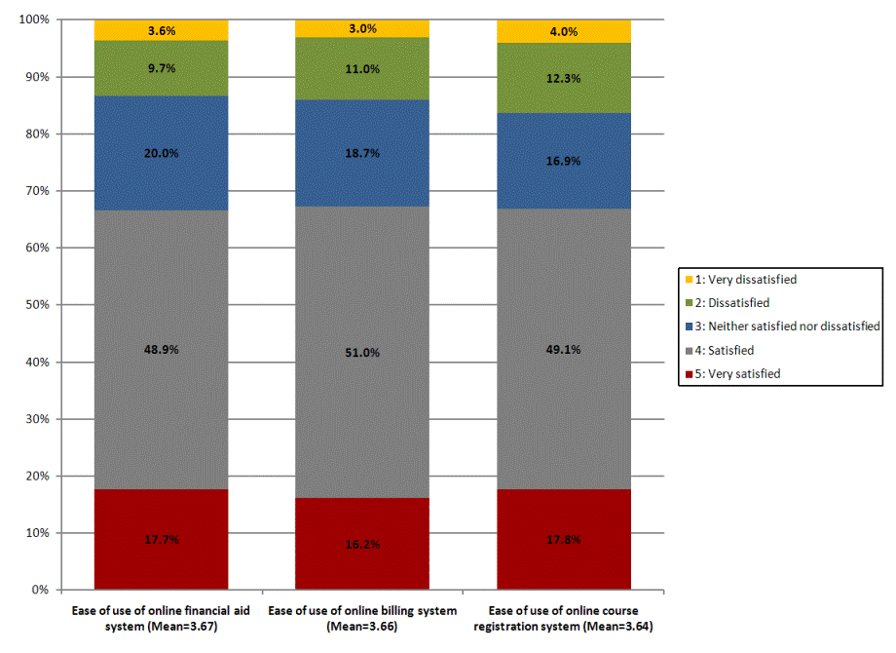
Financial Aid (Table 25; Figures 5 and 6)
While the majority of respondents are confident they will have the money to get their degree, one-in-ten respondents "disagree" (7.3%) or "strongly disagree" (3.4%) that they will have the financial resources they need to finish college, and another 21.1 percent appear uncertain (responding "neither agree nor disagree").
More than sixty percent (62.0%) of respondents said they had received some type of financial aid (e.g., scholarships, grants, loans, work-study) while at NC State. Almost 40 percent of those who received aid reported being "very satisfied" with their aid package (39.3%). Less than 13 percent were either "moderately" (9.0%) or "very dissatisfied" (3.4%) with their package. Large majorities of those receiving aid gave positive ratings to the customer service skills of the financial aid staff. Respondents were most likely to rate advisor staff as "excellent" (36.2%), followed by reception staff (33.5%) and phone staff (31.2%).
Table 25: Financial Resources to Finish College
 | Mean | 5: Strongly  agree | 4: Agree | 3: Neither agree  nor disagree | 2: Disagree | 1: Strongly  disagree
I will have the financial resources I need to finish college | 3.88 | 33.6% | 34.6% | 21.1% | 7.3% | 3.4%

Figure 5: Satisfaction with Financial Aid Package
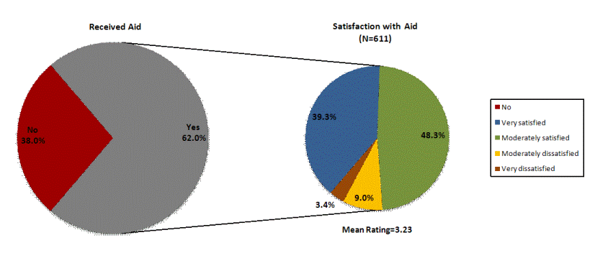

Figure 6: Customer Service Skills of Financial Aid Staff
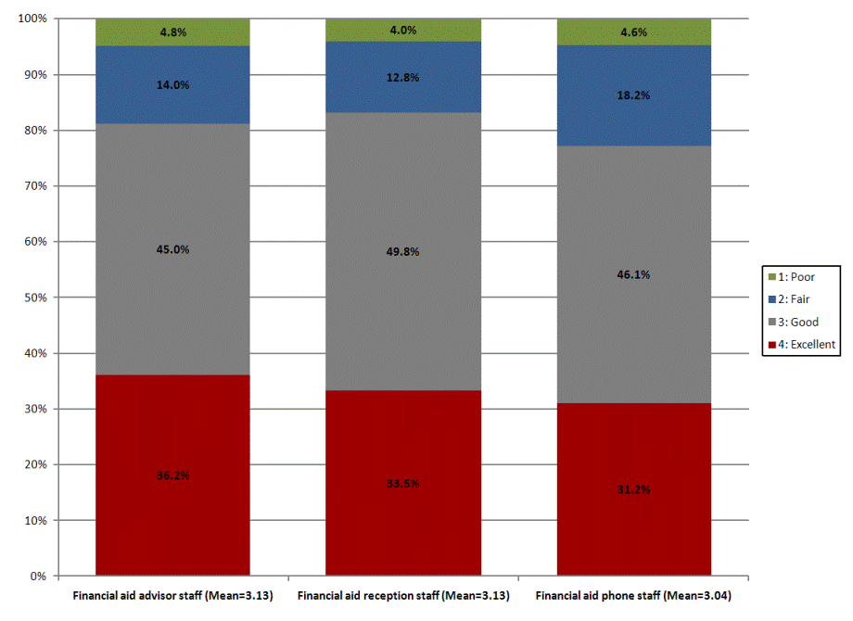

Knowledge, Skills, and Personal Development (Tables 26-28)
This section of the report focuses on respondents' perceptions of how well NC State has contributed to their academic and personal development. The 36 individual areas asked about relate to either general education, personal development, or world views goals that the University has for their education. Contributions were rated on a scale of 1 ("not at all") to 4 ("very much"). "Don't know" responses were excluded from the analyses.
General Education Goals:
Overall, respondents were satisfied with the extent to which NC State met their general education goals. Over three-fourths of respondents said NC State contributed "very much" or "somewhat" to 18 of the 20 general education goals. Average ratings were highest for problem-solving skills (3.34) and logical reasoning skills (3.30). While still receiving positive ratings by a majority, respondents gave some of the lowest ratings to questions pertaining to NC State's contribution to the general education goals of appreciating the humanities (e.g., literature, philosophy, religion, history, etc.) and appreciating the arts (e.g., music, art, theater, etc.) which received ratings of "very little" or "not at all" by 30 percent or more respondents (30.5% and 36.6%, respectively).
Personal Development Goals:
Respondents gave high ratings to the extent to which NC State met their personal development goals. Positive ratings were given by three-fourths or more respondents for each of the 16 personal development items asked about. Highest average ratings were given to independence and self-reliance (3.37) and lowest average ratings to exercising public responsibility and community service (2.99).
World View Goals:
Respondents were generally satisfied with NC State's contribution to their development of world views. Ability to work with people from diverse backgrounds (3.20) received the highest average ratings and understanding the potential impacts of climate change (2.86) received the lowest.
Table 26: Contribution to General Education Goals
 | Mean | 4: Very much | 3: Somewhat | 2: Very little | 1: Not at all
Problem-solving skills | 3.34 | 45.1% | 45.2% | 8.6% | 1.1%
Logical reasoning skills | 3.30 | 43.4% | 45.4% | 9.1% | 2.1%
Enhancing analytic skills | 3.28 | 40.6% | 48.3% | 9.7% | 1.4%
Using mathematical skills | 3.25 | 42.8% | 42.5% | 11.8% | 2.8%
Ability to plan and carry out projects independently | 3.25 | 38.6% | 49.8% | 9.8% | 1.7%
Ability to critically analyze ideas and information | 3.24 | 36.4% | 52.8% | 8.8% | 2.0%
Comprehension skills (understanding written information) | 3.21 | 37.0% | 49.0% | 12.4% | 1.6%
Applying scientific methods of inquiry | 3.19 | 39.9% | 42.4% | 14.5% | 3.3%
Using books, journals, articles from the library/internet etc. for research paper/project | 3.19 | 39.9% | 41.7% | 16.3% | 2.1%
Ability to adapt to changing technologies | 3.19 | 36.8% | 48.0% | 13.0% | 2.2%
Understanding how science and technology influence everyday life | 3.18 | 38.4% | 45.2% | 12.8% | 3.6%
Listening skills | 3.14 | 34.1% | 49.5% | 12.6% | 3.8%
Ability to organize the steps to successfully complete a group project | 3.12 | 32.8% | 49.2% | 15.1% | 2.8%
Developing computer skills | 3.06 | 35.0% | 41.8% | 17.2% | 6.0%
Understanding of diverse cultures and values | 3.05 | 31.6% | 47.1% | 16.4% | 4.9%
Applying social science methods to understand human behavior | 3.02 | 31.1% | 46.0% | 17.1% | 5.8%
Speaking skills | 3.02 | 29.4% | 47.8% | 17.8% | 5.0%
Writing skills | 3.01 | 27.4% | 51.2% | 17.1% | 4.4%
Appreciating the humanities (e.g., literature, philosophy, religion, history, etc.) | 2.89 | 29.5% | 40.0% | 20.6% | 9.9%
Appreciating the arts (e.g., music, art, theater, etc.) | 2.74 | 23.6% | 39.7% | 23.5% | 13.1%

Table 27: Contribution to Personal Development Goals
 | Mean | 4: Very much | 3: Somewhat | 2: Very little | 1: Not at all
Independence and self-reliance | 3.37 | 49.3% | 41.0% | 7.1% | 2.6%
Potential for success | 3.34 | 47.0% | 42.9% | 7.5% | 2.5%
Personal growth | 3.33 | 45.5% | 44.6% | 7.7% | 2.2%
Taking responsibility for my own behavior | 3.31 | 44.7% | 44.1% | 8.8% | 2.4%
Self-discipline | 3.30 | 42.8% | 46.9% | 8.2% | 2.1%
Coping with change | 3.28 | 43.4% | 43.4% | 10.4% | 2.7%
Time management | 3.25 | 42.8% | 42.7% | 11.5% | 3.0%
Ability to function as part of a team | 3.25 | 39.1% | 48.7% | 10.3% | 1.9%
Valuing learning as a lifelong process | 3.24 | 42.4% | 43.3% | 10.6% | 3.7%
Sense of personal identity | 3.16 | 38.3% | 43.8% | 13.6% | 4.3%
Self-confidence | 3.15 | 36.9% | 45.1% | 13.9% | 4.1%
Ability to lead or guide others | 3.15 | 33.5% | 50.4% | 13.1% | 2.9%
Ability to handle stress | 3.12 | 37.0% | 44.0% | 13.4% | 5.7%
Recognizing and acting upon ethical principles | 3.11 | 34.1% | 47.1% | 14.6% | 4.2%
aintaining an active and healthy lifestyle | 3.09 | 34.9% | 44.6% | 14.4% | 6.0%
Exercising public responsibility and community service | 2.99 | 29.8% | 45.2% | 19.6% | 5.5%
Table 28: Contribution to World View Goals
 | Mean | 4: Very much | 3: Somewhat | 2: Very little | 1: Not at all
Ability to work with people from diverse backgrounds | 3.20 | 39.9% | 44.8% | 10.7% | 4.6%
Understanding issues and problems facing the world | 3.16 | 36.4% | 46.7% | 13.0% | 3.8%
Appreciating gender equity | 3.13 | 37.2% | 44.8% | 12.2% | 5.8%
Appreciating racial equity | 3.12 | 37.5% | 43.7% | 12.2% | 6.5%
Developing a tolerance for divergent views | 3.10 | 32.3% | 49.5% | 13.6% | 4.6%
Understanding the commonality of human problems through a global perspective | 3.07 | 31.8% | 47.7% | 15.6% | 4.8%
Understanding the present as it relates to historical events and processes | 3.06 | 31.8% | 47.8% | 15.1% | 5.2%
Understanding the concepts of environmental sustainability | 3.04 | 32.0% | 45.6% | 16.6% | 5.8%
Appreciating differences in sexual orientation | 2.91 | 30.7% | 40.5% | 17.9% | 11.0%
Understanding the potential impacts of climate change | 2.86 | 27.2% | 43.6% | 17.7% | 11.5%

Employment and Extracurricular Activities
This section of the report focuses on employment rates, work hours, and involvement in extracurricular activities among sophomores at NC State.
Employment (Tables 29; Figures 7-9)
Half of the sophomore respondents indicated that they were employed during the 2009-2010 academic year (49.5%). The majority of employed respondents (55.1%) worked off campus only, with another 12 percent working both off and on campus. Respondents who worked off campus were slightly more likely than those working on campus to report working more than 20 hours per week (18.9% vs. 14.7%, respectively). While 46.2 percent of the employed respondents believe that their job "does not interfere with their school work," a similar number say it takes "some time" (47.8%) away from their school work, and 6 percent say their job takes "a lot of time" (6.0%) away from their school work.
Forty-five percent of those respondents who worked on campus reported that their job was at least somewhat (28.2%), if not directly (17.4%), related to their academic major. This proportion drops slightly, to 34 percent, among those respondents working off-campus (12.9% directly related; 20.7% somewhat related). In either case, when the job was unrelated to the respondent's major, it was more likely than not to be by choice.
Figure 7: Employment During Academic Year
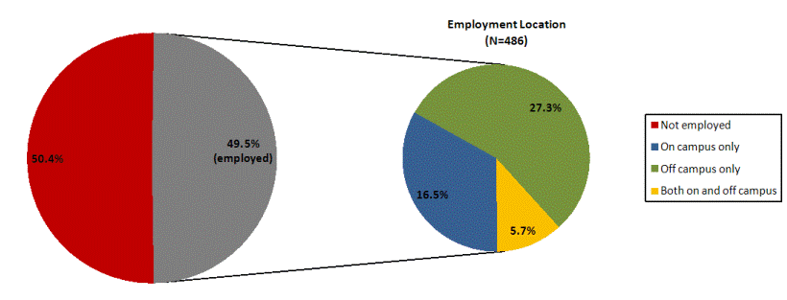

Figure 8: Number of Hours Worked
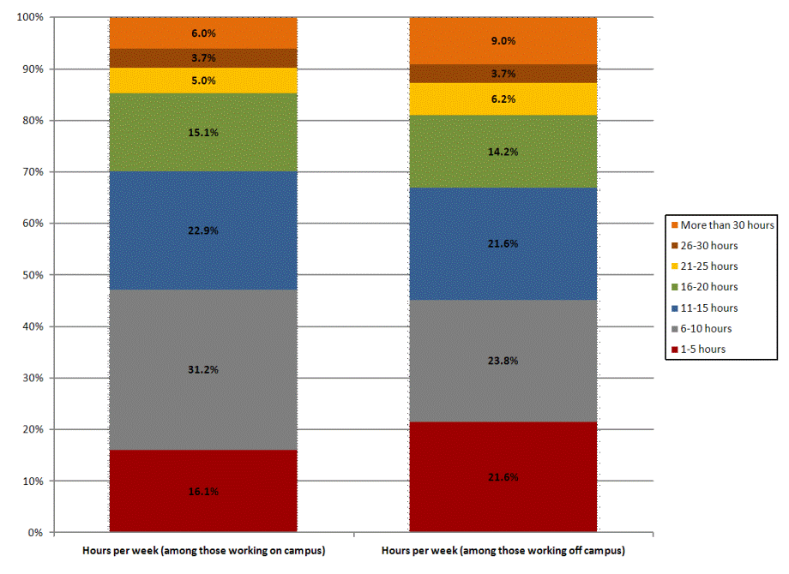
Table 29: Impact of Job on School Work
How job affects school work (among employed respondents) | % | N
My job does not interfere with my school work | 46.2% | 224
My job takes some time away from my school work | 47.8% | 232
My job takes a lot of time away from my school work | 6.0% | 29

Figure 9: Job Relationship to Academic Major
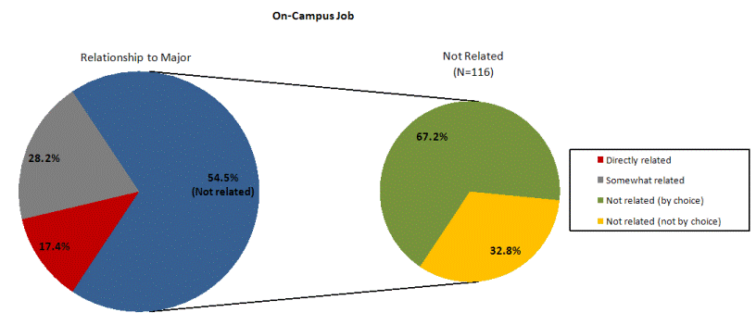
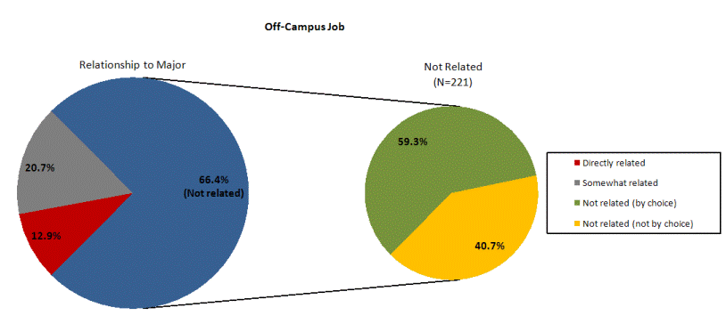
Involvement in Campus Activities (Tables 30-32)
Sophomores were asked to indicate the campus activities in which they were involved. Respondents most commonly reported being involved in intramural/recreational sports/club teams (40.6%), organizations/clubs related to your major (39.8%), and religious groups (21.3%).
Sophomores were also asked the frequency at which they participated in various campus activities. Students were most likely to report at least occasionally participating in workshops, seminars, speakers, etc. outside of class, with less than 30 percent saying they have "never" done such a thing during their time at NC State. Respondents were least likely to have ever participated in multicultural/diversity events/programs or co-curricular activities with 55.9 percent and 54.0 percent, respectively, saying they had "never" participated in these types of activities at NC State. However, the frequency of participation in co-curricular activities among those who said they had ever done this type of thing was much higher than for other activities asked about, with 34.4% of participants saying they do so "one or more times a week". So, although less than half of respondents participate in co-curricular activities, those who do participate are likely to so on a regular basis.
With one exception, sophomores are generally satisfied with opportunities for involvement on campus. One-half or more respondents reported being at least "satisfied" with opportunities for community service/volunteer work (59.5%), opportunities to interact with/learn from diverse people (58.0%), opportunities to develop leadership skills (56.9%), and the ease with which one can get involved in campus organizations (55.3%). Substantially fewer respondents were satisfied with weekend activities on campus for students (38.4%).
Table 30: Involvement in Campus Activities
 | % | N
Intramural/Recreational Sports, Club Teams | 40.6% | 405
Organizations/Clubs related to your major | 39.8% | 397
Religious groups | 21.3% | 213
Service groups | 16.9% | 169
University Scholars Program | 14.2% | 142
Social fraternity/sorority | 12.2% | 122
Minority student groups | 8.8% | 88
Visual/Performing Arts/Music Groups | 7.4% | 74
Academic scholarship program (Caldwell, Park, etc.) | 6.2% | 62
Residence Hall Council, IRC | 4.9% | 49
Varsity Athletic Teams | 3.9% | 39
Political/Issue groups | 3.8% | 38
University Honors Program | 3.8% | 38
Student Government | 2.6% | 26
Student Media/Publications | 2.3% | 23
Union Activities Board groups | 2.0% | 20
ROTC | 1.3% | 13

Table 31: Frequency of Participation in Campus Activities
 | 1 or more times  a week | 2-3 times a month | Once a month | 2-3 times a semester | 1-2 times a year | Never
Workshops, seminars, speakers, etc. outside of class | 3.8% | 10.1% | 12.0% | 16.6% | 29.3% | 28.2%
University sponsored art events | 2.3% | 6.0% | 10.1% | 17.1% | 30.9% | 33.5%
Multicultural/diversity events/programs | 1.9% | 3.9% | 7.1% | 12.0% | 19.1% | 55.9%
Community service/volunteer work | 3.8% | 8.5% | 12.0% | 17.3% | 22.3% | 36.1%
Intramural activities | 13.5% | 12.3% | 6.2% | 11.4% | 14.9% | 41.7%
Co-curricular activities | 15.8% | 6.8% | 7.3% | 6.3% | 9.9% | 54.0%
Intercollegiate athletic events | 11.5% | 20.0% | 12.0% | 12.9% | 9.2% | 34.4%

Table 32: Satisfaction with Opportunities for Involvement
 | Mean | 5: Very  satisfied | 4: Satisfied | 3: Neither satisfied  nor dissatisfied | 2: Dissatisfied | 1: Very  dissatisfied
Opportunities for community service/volunteer work | 3.67 | 14.4% | 45.1% | 34.1% | 5.4% | 0.9%
Opportunities on campus to interact with/learn from diverse people | 3.65 | 13.8% | 44.2% | 36.3% | 4.6% | 1.1%
Opportunities on campus to develop leadership skills | 3.63 | 13.3% | 43.6% | 36.8% | 5.6% | 0.7%
The ease with which I can get involved in campus organizations | 3.55 | 12.4% | 42.9% | 33.5% | 9.6% | 1.5%
Weekend activities on campus for students | 3.24 | 7.1% | 31.3% | 43.2% | 15.6% | 2.8%

For more information on the 2010 Sophomore Survey contact:
Dr. Nancy Whelchel, Assistant Director for Survey Research
University Planning and Analysis
Box 7002
NCSU
Phone: (919) 515-4184
Email: Nancy_Whelchel@ncsu.edu
Posted: July, 2010

